# **Format for uploading details in GitHub and Slack in word file format**

**Student Name: Shrinivasa**

**Class and Sec: VI B**

**USN: 4AL17CS092**

|  |  |  |  |  |
| --- | --- | --- | --- | --- |
| **Online Test Details** | | | | |
| **Subject** |  | | | |
| **Semester** | **VI - B** | | **Duration** | **Minutes** |
| **%** | | **/** | | |

**Encl: snapshot of the test result**

|  |  |  |  |
| --- | --- | --- | --- |
| **Certification Course Details** | | | |
| **Course** | **Introduction to Cloud** | | |
| **Certificate Provider** | **Cognitiveclass.ai** | **Duration** | **6 hours** |

**Encl: snapshots of the daily class activities (at least two snap shots)**

**Progress on 12-06-2020**







|  |  |
| --- | --- |
| **Coding Challenges** | |
| **Problem Statement: Pro1(python), Pro2(python), Pro3(python).** | |
| **Status: Completed** | |
| **Uploaded the report both in GitHub & Slack** | **Yes** |

**Encl: snapshots of your response to challenge.**

[**https://github.com/Shrinivasakunder/certification-and-online-coding/tree/master/Online%20coding**](https://github.com/Shrinivasakunder/certification-and-online-coding/tree/master/Online%20coding)

**1. Python program to Count the Number of Vowels Present in a String using Sets Step1: Get a string Step2: find the no of occurrence of all vowels in the string using data structure set.**

s = input("Enter The String: ")

v = set("aeiouAEIOU")

c = 0

for i in s:

if i in v:

c += 1

print("The Number Of Occurrence All Vowels In A String: ", c)

**Output:**

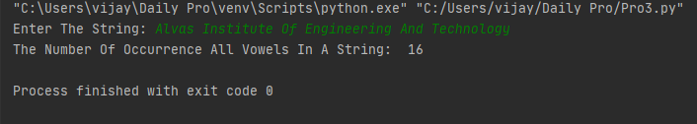

**2. A magic square of order n is an arrangement of n^2 numbers, usually distinct integers, in a square, such that the n numbers in all rows, all columns, and both diagonals sum to the same constant. A magic square contains the integers from 1 to n^2.**

def gSqua(n):

magic_square = [[0 for x in range(n)] for y in range(n)]

i = n / 2

j = n - 1

num = 1

while num <= (n * n):

if i == -1 and j == n:

j = n - 2

i = 0

else:

if j == n:

j = 0

if i < 0:

i = n - 1

if magic_square[int(i)][int(j)]:

j = j - 2

i = i + 1

continue

else:

magic_square[int(i)][int(j)] = num

num = num + 1

j = j + 1

i = i - 1

print("Magic Squre For n =", n)

print('Sum Of Each Row Or Column Or Diagonal: ', n * (n * n + 1) / 2, "\n")

for i in range(0, n):

for j in range(0, n):

print('%2d ' % (magic_square[i][j]), end='')

if j == n - 1:

print()

n = int(input("Enter The Number For Magic Square: "))

gSqua(n)

**Output:**

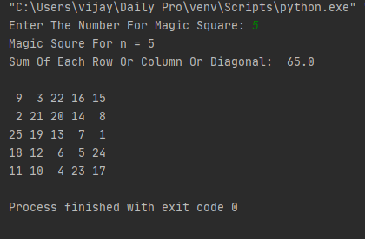

**3. Python program to print the pattern.**

n = int(input("Enter The N Value: "))

for i in range(1, n + 1):

print(" " * (n - i), "*" * i, end="\n")

for i in range(n - 1, 0, -1):

print(" " * (n - i), "*" * i, end="\n")

**Output:**

